EXERCISE 1: SETTING UP JUnit

Scenario: You need to set up JUnit in your Java project to start writing unit tests.

CalculatorTest.java:
import org.junit.Test;
import static org.junit.Assert.*;

public class CalculatorTest {

@Test
public void testAdd() {
Calculator calc = new Calculator();
int result = calc.add(2, 3);
System.out.println("✔ add(2, 3) = " + result); // Add this line
assertEquals(5, result);
}
}
Pom.xml(JUnitDemo):
<project xmlns="http://maven.apache.org/POM/4.0.0"
xmlns:xsi="http://www.w3.org/2001/XMLSchema-instance"
xsi:schemaLocation="http://maven.apache.org/POM/4.0.0
http://maven.apache.org/xsd/maven-4.0.0.xsd">
<modelVersion>4.0.0</modelVersion>
<groupId>com.example</groupId>
<artifactId>JUnitDemo</artifactId>
<version>1.0-SNAPSHOT</version>

<dependencies>
<dependency>
<groupId>junit</groupId>
<artifactId>junit</artifactId>
<version>4.13.2</version>
<scope>test</scope>
</dependency>
</dependencies>
</project>

Calculator.java:
public class Calculator {
public int add(int a, int b) {
return a + b;
}
}

OUTPUT:
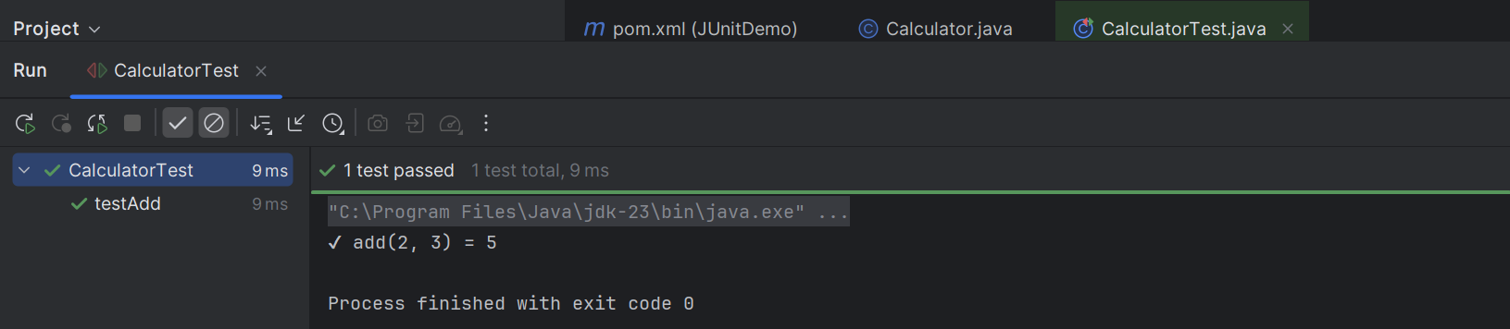

EXERCISE 3: ASSERTIONS IN JUnit

Scenario: You need to use different assertions in JUnit to validate your test results.
AssertionsTest.java:
import org.junit.Test;
import static org.junit.Assert.*;

public class AssertionsTest {
@Test
public void testAssertions() {
System.out.println("Running assertions...");

// Assert equals
assertEquals(5, 2 + 3);
System.out.println("assertEquals passed");

// Assert true
assertTrue(5 > 3);
System.out.println("assertTrue passed");

// Assert false
assertFalse(5 < 3);
System.out.println("assertFalse passed");

// Assert null
assertNull(null);
System.out.println("assertNull passed");

// Assert not null
assertNotNull(new Object());
System.out.println("assertNotNull passed");

System.out.println("All assertions passed successfully.");
}
}
Pom.xml(AssertionsJUnitProject):
<project xmlns="http://maven.apache.org/POM/4.0.0"
xmlns:xsi="http://www.w3.org/2001/XMLSchema-instance"
xsi:schemaLocation="http://maven.apache.org/POM/4.0.0 http://maven.apache.org/xsd/maven-4.0.0.xsd">
<modelVersion>4.0.0</modelVersion>
<groupId>com.example</groupId>
<artifactId>AssertionsJUnitProject</artifactId>
<version>1.0-SNAPSHOT</version>
<dependencies>
<dependency>
<groupId>junit</groupId>
<artifactId>junit</artifactId>
<version>4.13.2</version>
<scope>test</scope>
</dependency>
</dependencies>
</project>
OUTPUT:
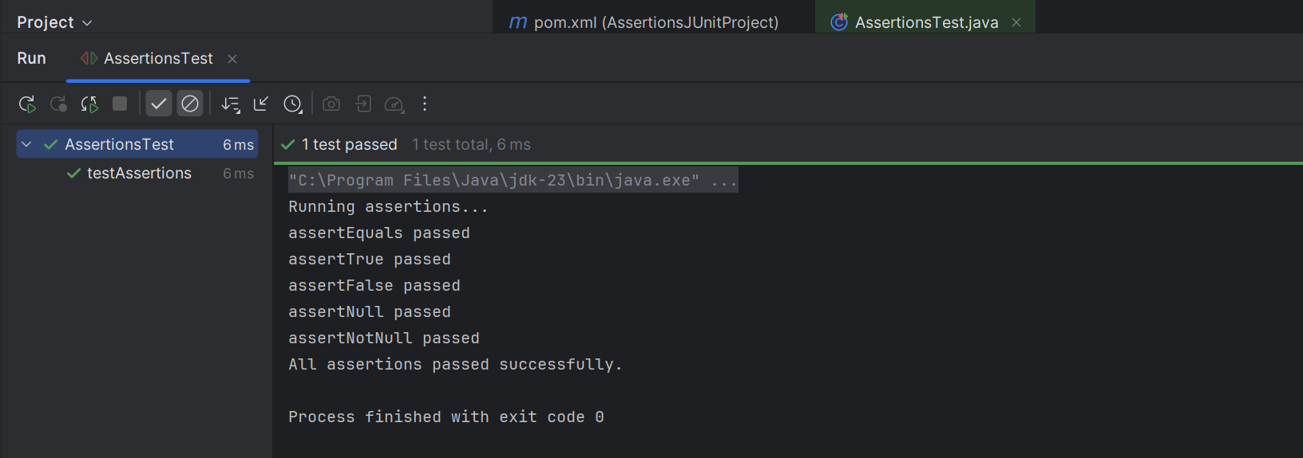
EXERCISE 4: ARRANGE – ACT – ASSERT(AAA) PATTERN , TEST FIXTURES, SETUP AND TEARDOWN METHODS IN JUnit

CalculatorTest.java:
package com.example;

import org.junit.After;
import org.junit.Before;
import org.junit.Test;
import static org.junit.Assert.assertEquals;

public class CalculatorTest {
private testAdd()

@Before
public void setUp() {
calculator = new Calculator();
System.out.println("Setup complete");
}

@After
public void tearDown() {
System.out.println("Teardown complete");
}

@Test
public void testAdd() {
// Arrange
int a = 5;
int b = 3;

// Act
int result = calculator.add(a, b);

// Assert
assertEquals(8, result);
}

@Test
public void testSubtract() {
// Arrange
int a = 5;
int b = 3;

// Act
int result = calculator.subtract(a, b);

// Assert
assertEquals(2, result);
}
}

Pom.xml:
<dependency>
<groupId>junit</groupId>
<artifactId>junit</artifactId>
<version>4.13.2</version>
<scope>test</scope>
</dependency>

OUPUT:
